**SEO search engine optimization:**

a methodology of strategies, techniques and tactics used to increase the amount of visitors to a website

by obtaining a high-ranking placement in the search results page of a search engine ranking placement (SERP) -- including Google, Bing, Yahoo and other search engines.

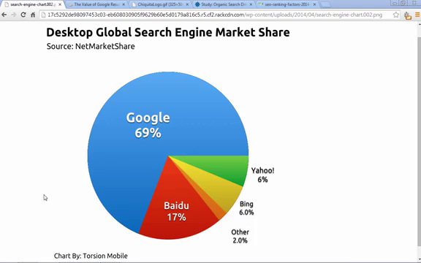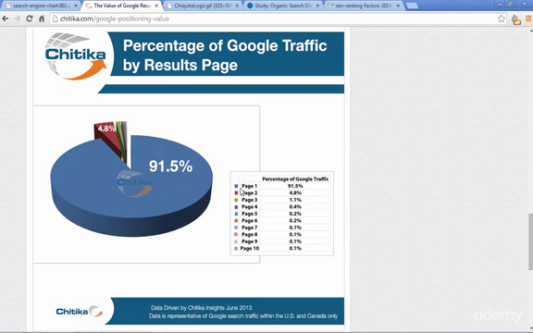

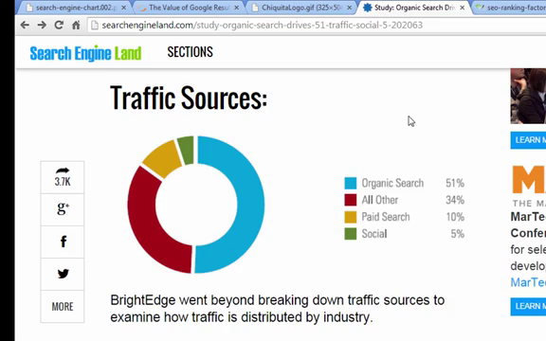

-google has a program or algorithm

-also based on number of twitter, fb feed and tweets

-off site number of links

-fast page loading

-image optimizing

-mobile view(reponsive)

-cloudflare-reverse proxy-offline version

-allow or enable cache and cookies

-optimize css and javascript (minimizing)

- get our website to google mobile friendly category

- description

-on page factors

-off page factors

-proof terms- tiger food or tiger driver

-301 redirect for outdated pages redirect from canonical url

-NOINDEX tag tells Google not to index a specific page

NOFOLLOW tag tells Google not to follow the links on a specific page(still page not finished)

NOARCHIVE tag tells Google not to store a cached copy of your page

NOSNIPPET tag tells Google not to show a snippet (description) under your Google listing, it will also not show a cached link in the search results

google tools:

pagespeed insight gives scores

webmaster tool

analytics

-gtmetrix use to checks speed and gives recommendation for high rank

-moz.com gives details about internal links

-“screaming frog for seo” a software

-soovle.com shows keywords for different search engines ubersuggest.org keywordtool.io